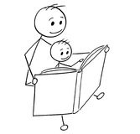Reading to your child at home –

Why doing so every day is so important.

Research shows that the first 3-5 years of a child’s life is when the most rapid growth in the brain occurs. During this time everything the child is exposed to sets the stage for future learning.

* Reading to your child creates a nurturing atmosphere, similar to when they were a baby. It helps to create a positive association with books and reading. Being read to regularly also leads to better academic achievement in every area.
* Reading to your child will increase their vocabulary, which in turn improves their reading and writing.
* Listening to stories helps children to understand how they work, they learn about characters and settings, how stories start and end and become familiar with phrases which are used regularly, e.g. Once upon a time.
* Listening to stories regularly helps children to make predictions, develop rhyming skills, increases attention, logical thinking, imagination and curiosity.
* Plus, surveys of children have shown that over 80% of children love being read to.

Top tips for reading to your child at home:

* Set aside some time – every day find somewhere quiet and without any distractions.
* Let your child choose the book-even if it’s one they have heard lots of times already!
* Encourage them to hold the book and turn the pages.
* Talk about the book – make links to their life, talk about the illustrations, name the characters, guess what will happen next, talk about how the characters are feeling and how the book makes them feel.
* 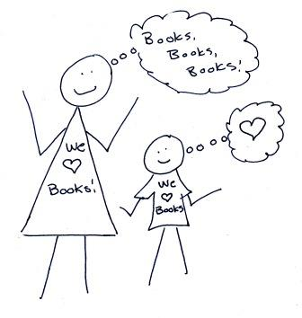Make it fun! – Enjoy this special time together!