[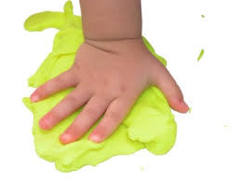](http://www.google.co.uk/imgres?imgurl=http://www.crosswaychurchwa.com/images/kids_hand_in_playdough_H.jpg&imgrefurl=http://www.crosswaychurchwa.com/serve/thebarnyard/barnyardarchive2012/august9/&h=267&w=356&tbnid=cTfRVhDRuEcJ9M:&zoom=1&docid=v1CvT8ibxzMetM&ei=HcsGVNC-KovgaPLHgPgB&tbm=isch&ved=0CHQQMyg0MDQ&iact=rc&uact=3&dur=864&page=3&start=35&ndsp=21)**Play Dough Activities** 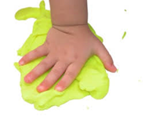

**Help to Improve your child’s Fine Motor/Small Movement Skills**

Activities using Play Dough are a great way to exercise the muscles of the hands to develop fine motor control and also to develop coordination skills.

Using both hands together or alternately develops bilateral coordination. Give your child a big lump of play dough, encourage them to:

* **Pound it and Squash it –** Use both hands in an alternating rhythm (this is quite hard because it demands bilateral co-ordination). Pound the dough then squash it into a ball again. Squashing helps to strengthen the hand muscles. Pounding and squashing dough is also a good stress reliever.
* **Pinch it, Poke it and Squeeze it –** Use both hands to squeeze the dough like the ‘hulk’. Pinch the dough with both hands between the thumb and index finger. Poke the dough with thumbs and individual fingers.
* **Roll balls –** Use both hands in a circular movement to roll the dough between the palms of the hands.
* **Roll sausages –** Roll the dough forwards and back on a flat surface.
* **Pinch pots –** Hold a ball of dough in one hand and use the thumb, index and middle finger of the other hand to shape the dough. Insert the thumb into the middle of a ball of dough then use the index and middle fingers to pinch the outside of the pot creating a small bowl shape. This is quite advanced it requires both hands to work together and is good for helping the development of finger strength required for writing.
* **Roll small balls –** Use the thumb, index and middle fingers to roll small balls. This encourages the development of the finger joints used for handwriting. (If you’re right handed try doing it with your left hand or vice versa, this will give you an idea of how challenging it is).

[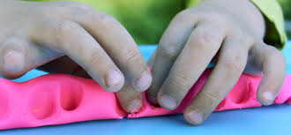](http://www.google.co.uk/imgres?imgurl=https://www.sensationalkids.co.za/images/uploads/playdough_the_mess_is_worth_it.jpg&imgrefurl=https://www.sensationalkids.co.za/news/article/2013/05/14/playdough-the-mess-is-worth-it.aspx&h=275&w=594&tbnid=JcewCaglBIk4YM:&zoom=1&docid=ZL_gCR4jqOAzdM&ei=Rs8GVIG3CM_daKP9gZgE&tbm=isch&ved=0CBgQMygQMBA4rAI&iact=rc&uact=3&dur=843&page=16&start=315&ndsp=23)

Give your child plenty of time to just explore the dough and use their imagination to create things. You can add buttons, feathers, lolly sticks, shells to further fire their imagination.

A variety of tools can also be used to develop fine motor skills and coordination such as:

* Rollers
* Children’s scissors
* Garlic press
* Textured object to make patterns e.g. potato masher, stickle bricks, wheels of toy car
* Combs