Finger Rhymes
and Songs

For 3 to 5yr olds

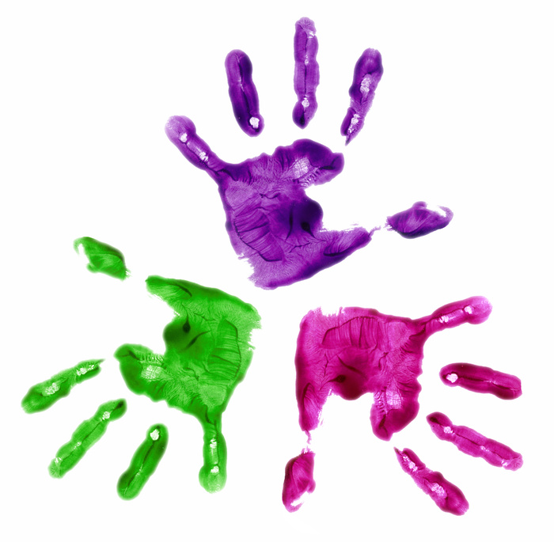

Songs and rhymes that will strengthen children’s hands and fingers and develop small movement skills
Five Little Peas

Five little peas in a pea-pod pressed,
(make a fist, palm down)
One grew, two grew, and so did all the rest;
(stretch out index finger then other fingers slowly)
They grew and grew and did not stop,
Until one day the pod went … POP!
(clap hands together)

A House

Here is a nest for a sparrow,
(cup hands together)
Here is a hive for a bee,
(put fists together)
Here is a hole for a rabbit,
(make a circle both hands together)
And here is a house for me’
(place fingertips together above head)

The Barber’s Shop

Mr Barber, cut my hair,
(scissor fingers across forehead)
While I sit in a great big chair.
(pat thighs)
Cut a little here,
(clap hands by right ear)
Cut a little there.
(clap hands by left ear)
Mr Barber, cut my hair.



Ten Fat Sausages

Ten fat sausages sizzling in the pan,
Ten fat sausages sizzling in the pan,
(stretch out thumbs and fingers and wiggle)
One went POP! And another went BANG!
(click fingers – pop, then clap - bang)
Then there were eight fat sausages sizzling in the pan.

Eight fat sausages … etc.

No fat sausages sizzling in the pan,
No fat sausages sizzling in the pan,
But all of a sudden, the pan went BANG!
Now there are no fat sausages –
And no frying pan!

A nest is a house for a sparrow,
(cup both hands together)
A hive is a house for a bee,
(put fists together)
A hole is a house for a rabbit,
(make a circle with both hands)
But a house is a house for me,
(place fingertips together above head)

A Ball

A great big ball,
(make a large circle touching fingertips above head)
A middle-sized ball,
(make a circle touching thumbs and fingers of both hands together)
A little ball I see,
(make a circle touching thumb and index finger, of same hand, together)

One, Two, Three, Four, Five

One, two, three, four, five,
(count on fingers to five)
Once I caught a fish alive;
(wiggle hand like fish)
Six, seven, eight, nine, ten,
(continue counting on fingers to ten)
Then I let it go again.
Five Little Ducks

Five little ducks went swimming one day,
Over the pond and far away.
Mother Duck said ‘Quack, quack, quack, quack’,
But only four little ducks came back.

Four little ducks … etc

One little duck went swimming one day,
Over the pond and far away.
Mother Duck said ‘Quack, quack, quack, quack’,
But no little ducks came swimming back.

Mother Duck went swimming one day,
Over the pond and far away.
Mother Duck said ‘Quack, quack, quack, quack’,
And five little ducks came swimming back.

Use the fingers of one hand to represent the little ducks. Use the other hand to represent the Mother Duck’s bill to say ‘Quack, quack, quack, quack’

Beehive

Here is a beehive.
(cup hands together)
Where are all the bees?
Hiding inside where nobody sees.
(peek inside cupped hands)
Look here they come, out of the hive,
One, two, three, four, five!
(hold up thumb and fingers as you count)
Buzz-zzzzz!
(wiggle fingers in air as they fly away)

(pretend to throw fish back)
Why did you let it go?
(shake hand as if it hurts)
Because it bit my finger so!
Which finger did it bite?
This little finger on my right!
(hold up little finger of right hand)

Here’s a Cup

Here’s a cup, and here’s a cup,
(make a fist with one hand, then fist with the other hand)
And here’s a pot of tea.
(extend thumb of one hand)
Pour a cup, pour a cup,
(pretend to pour tea into cup)
And have a cup with me!
(pretend to drink, extend little finger)

Five Currant Buns

Five currant buns in a baker’s shop,
(hold up five fingers on one hand)
Round and fat with sugar on the top.
(make a circle, thumbs and fingertips of both hands together – then pretend to sprinkle sugar, rubbing thumb and fingertips together)
Along came a child with a penny one day,
Bought a currant bun and took it away.
(hold up four fingers on one hand)
Four currant buns … etc

Variations
Five chocolate barfis in a baker’s shop,
Square and fat with chocolate on the top.

Five butter croissants in a baker’s shop,
Soft and fluffy with sugar on the top.

Five mince pies in a baker’s shop,
Warm and spicy with sugar on the top.

Five Little Monkeys

Five little monkeys jumping on the bed,
(bounce fingers of one hand on palm of the other)
One fell off and bumped his head;
(roll hand over hand towards floor)
His mother called the doctor
(pretend to use phone)
And the doctor said,
‘No more monkey business - jumping on the bed!’

Four little monkeys … etc

One little monkey jumping on the bed
She/he fell off and bumped his head;
His mother called the doctor
And the doctor said,
‘Well that’s what you monkeys get for jumping on the bed!’

